**Lab_Day-3 ANP-C9180 (Programming Statements)**

**Q1. Using input () function take one number from the user and using ternary operators check whether the number is even or odd**

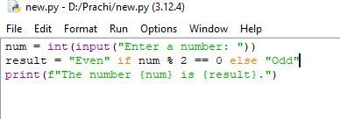

**OUTPUT:**

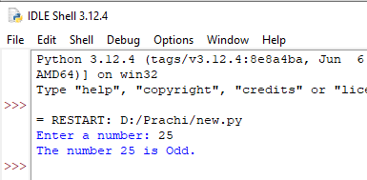

**Q2. Using input function take two number and then swap the number**

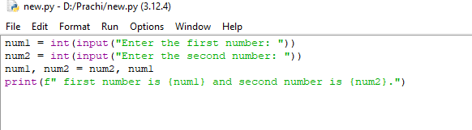

**OUTPUT:**

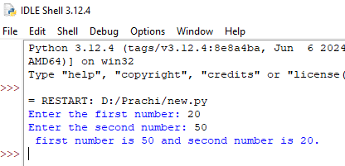

**Q3. Write a Program to Convert Kilometers to Miles**

**The formula to convert kilometers to miles is:**

**Miles=Kilometers×0.621371**

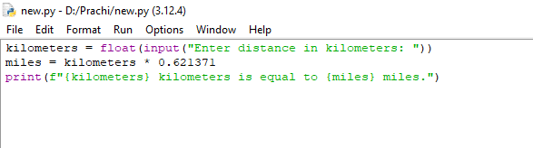

**OUTPUT:**

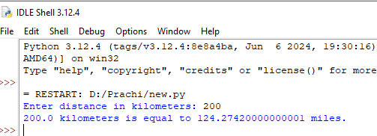

**Q4. Find the Simple Interest on Rs. 200 for 5 years at 5% per year.**

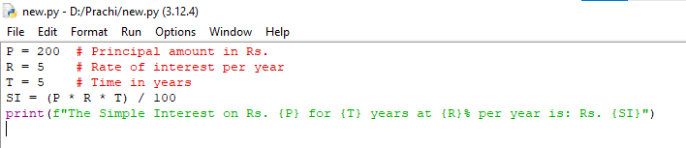

**OUTPUT:**

